DATABASE PER MICROSERVICE
Customer_service
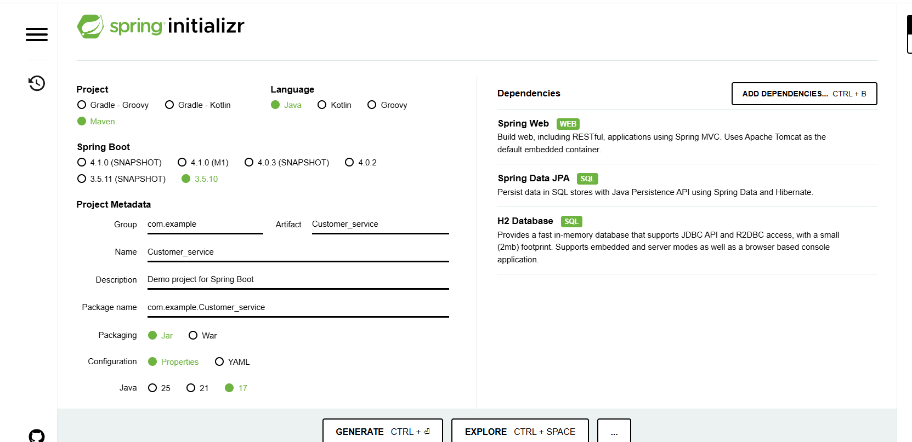
H2 is a small, lightweight Java database that runs inside your Spring Boot application.
Often used for testing / demo / learning
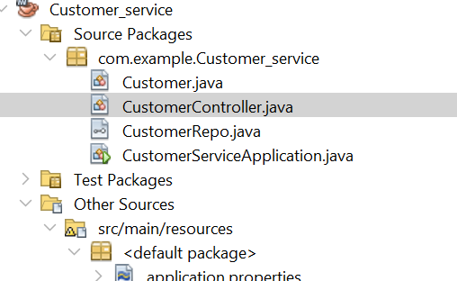
Inside it you have Java files:
- Customer.java → usually the model/entity (Customer details/fields)
- CustomerController.java → the REST API controller (handles URL requests)
- CustomerRepo.java → the repository (talks to DB using JPA). It is the class/interface that connects your Java code to the database.
- CustomerServiceApplication.java → the main Spring Boot class (starts the app)
JPA = Java Persistence API
It is a standard way in Java to store and read objects from a database.
- Without JPA: you write SQL manually (SELECT, INSERT, etc.)
- With JPA: you work with Java objects (Customer) and JPA converts it to SQL automatically.

Customer.java
package com.example.Customer_service;

import jakarta.persistence.*;

@Entity
public class Customer {
@Id @GeneratedValue
public Long id;
public String name;
}
CustomerController.java
package com.example.Customer_service;

import org.springframework.web.bind.annotation.*;
import java.util.List;

@RestController
public class CustomerController {
private final CustomerRepo repo;
public CustomerController(CustomerRepo repo) { this.repo = repo; }

@PostMapping("/customers")
public Customer add(@RequestBody Customer c) { return repo.save(c); }

@GetMapping("/customers")
public List<Customer> all() { return repo.findAll(); }
}

CustomerRepo.java
package com.example.Customer_service;

import org.springframework.data.jpa.repository.JpaRepository;

public interface CustomerRepo extends JpaRepository<Customer, Long> { }

CustomerServiceApplication.java

package com.example.Customer_service;

import org.springframework.boot.SpringApplication;
import org.springframework.boot.autoconfigure.SpringBootApplication;

@SpringBootApplication
public class CustomerServiceApplication {

public static void main(String[] args) {
SpringApplication.run(CustomerServiceApplication.class, args);
}

}
Application propoerties

spring.application.name=Customer_service
server.port=8081
spring.datasource.url=jdbc:h2:file:./data/customerdb
spring.datasource.driverClassName=org.h2.Driver
spring.datasource.username=sa
spring.datasource.password=

spring.jpa.hibernate.ddl-auto=update

spring.h2.console.enabled=true
spring.h2.console.path=/h2
Customer DB view

http://localhost:8081/h2
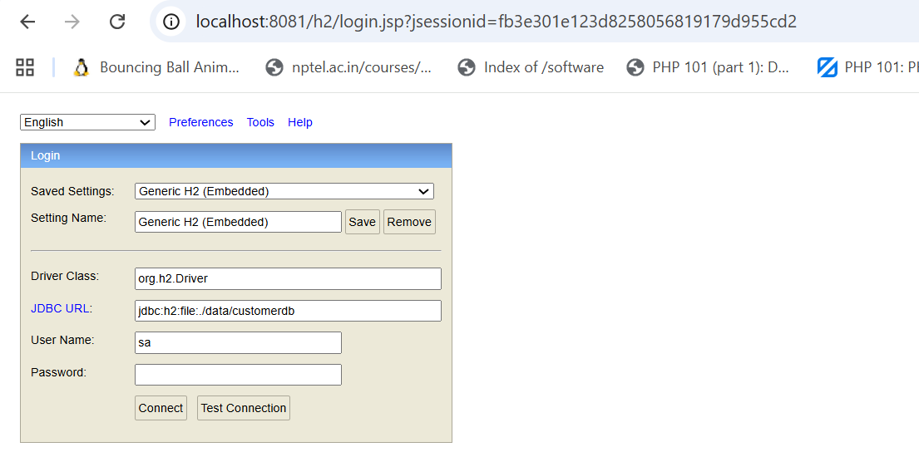
Click connect,
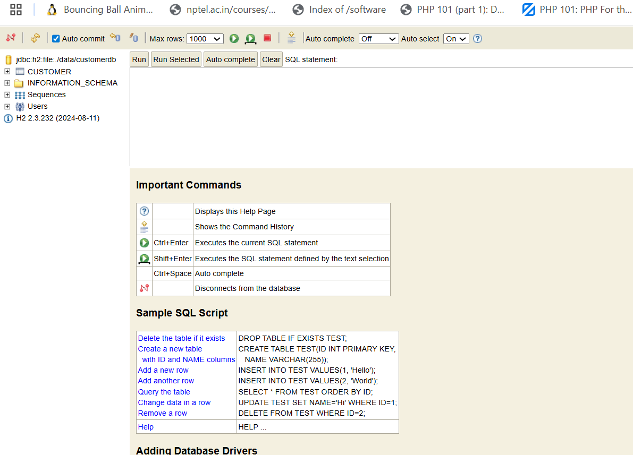
INSERT INTO CUSTOMER (ID,NAME) VALUES (3,'nancy');
select * from customer;
curl -X POST http://localhost:8081/customers -H "Content-Type: application/json" -d "{\"name\":\"Anny\"}"
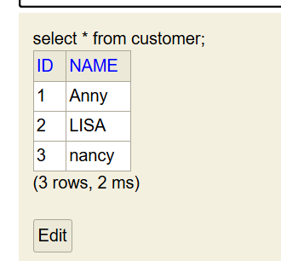
After you type jdbc:h2:file:./data/customerdb, do these steps:
- User Name: sa
- Password: (leave it empty)
- Click Connect
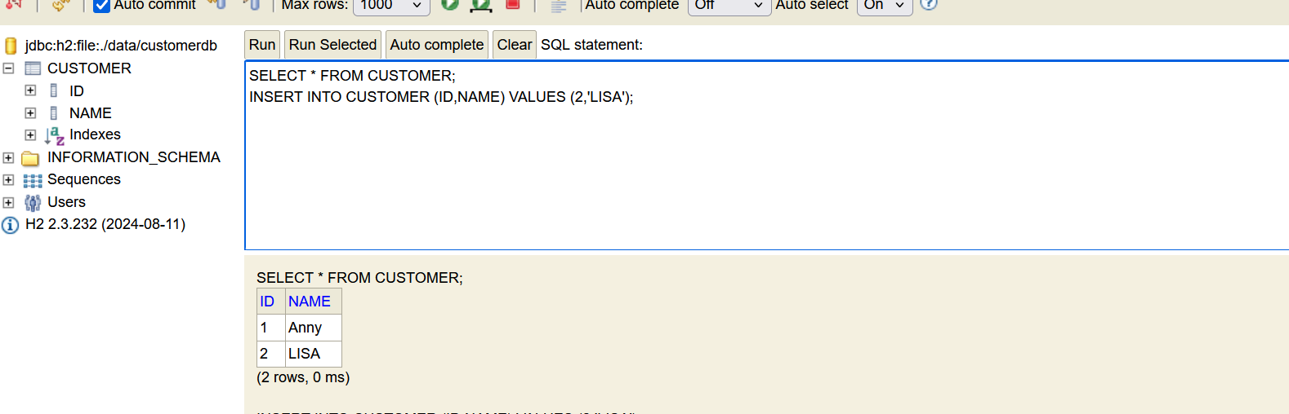
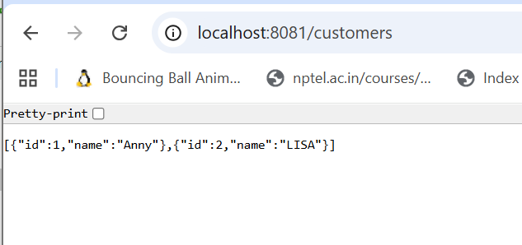
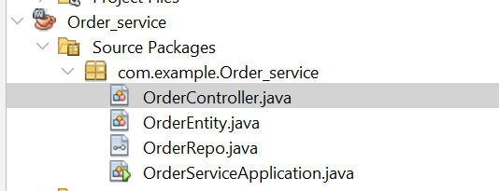
OrderController.java

package com.example.Order_service;

import org.springframework.web.bind.annotation.*;
import java.util.List;

@RestController
public class OrderController {
private final OrderRepo repo;
public OrderController(OrderRepo repo) { this.repo = repo; }

@PostMapping("/orders")
public OrderEntity add(@RequestBody OrderEntity o) { return repo.save(o); }

@GetMapping("/orders")
public List<OrderEntity> all() { return repo.findAll(); }
}

OrderEntity.java

package com.example.Order_service;

import jakarta.persistence.*;

@Entity
public class OrderEntity {
@Id @GeneratedValue
public Long id;
public String item;
}

OrderRepo.java

package com.example.Order_service;
import org.springframework.data.jpa.repository.JpaRepository;
public interface OrderRepo extends JpaRepository<OrderEntity, Long> { }

OrderServiceApplication.java

package com.example.Order_service;

import org.springframework.boot.SpringApplication;
import org.springframework.boot.autoconfigure.SpringBootApplication;

@SpringBootApplication
public class OrderServiceApplication {

public static void main(String[] args) {
SpringApplication.run(OrderServiceApplication.class, args);
}

}

Order application.properties
spring.application.name=Order_service
server.port=8082
spring.datasource.url=jdbc:h2:file:./data/orderdb
spring.datasource.driverClassName=org.h2.Driver
spring.datasource.username=sa
spring.datasource.password=

spring.jpa.hibernate.ddl-auto=update

spring.h2.console.enabled=true
spring.h2.console.path=/h2

For Order service, db view
Open:
http://localhost:8082/h2
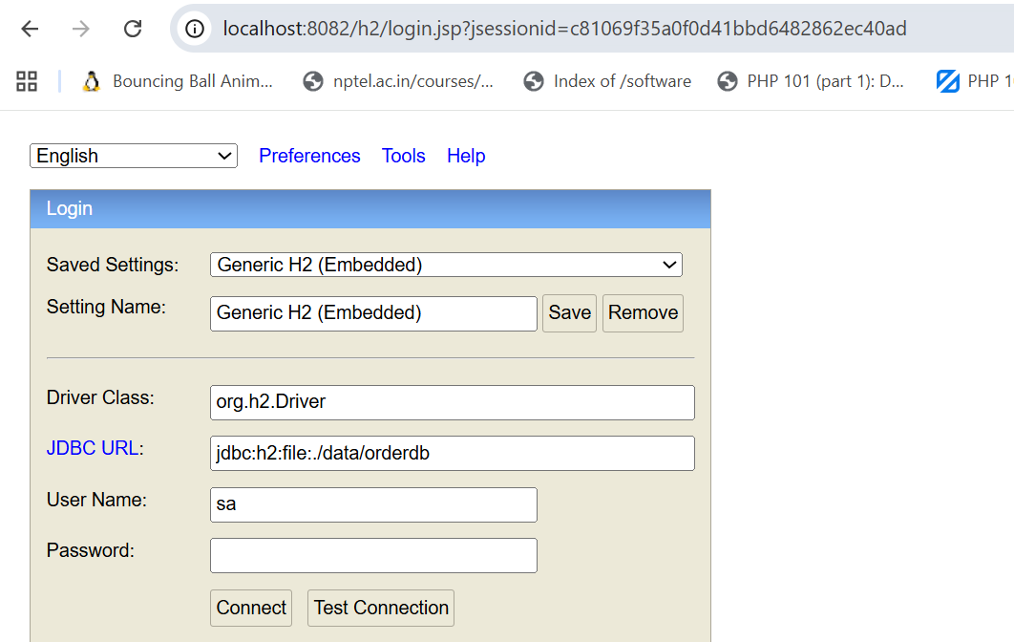
SHOW TABLES;
INSERT INTO ORDER_ENTITY (ID,ITEM) VALUES (2,'Book');
SELECT * FROM ORDER_ENTITY;
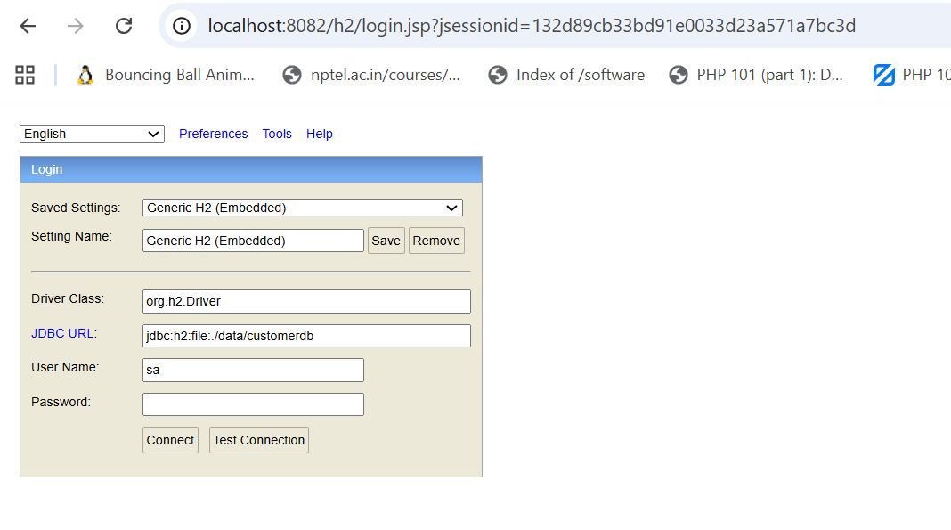
JDBC URL: jdbc:h2:file:./data/orderdb
Click connect
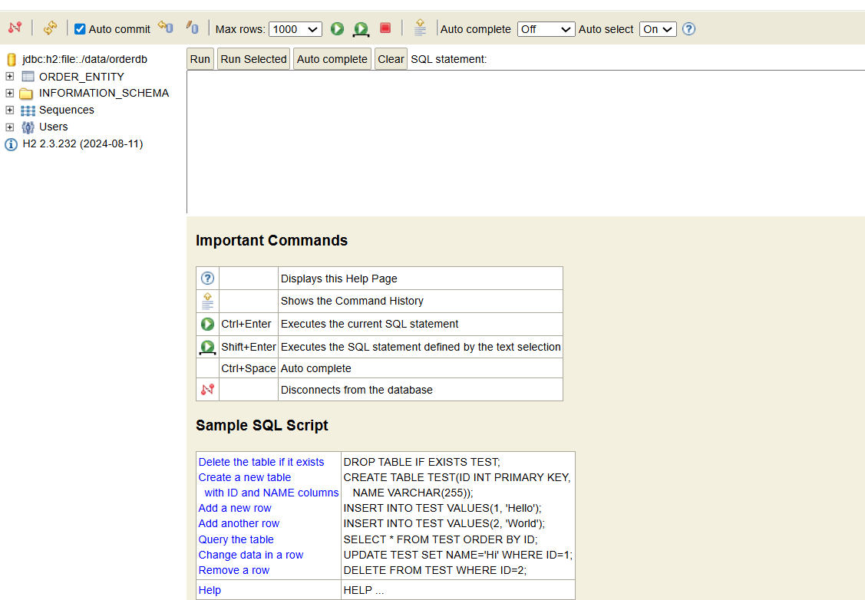
INSERT INTO ORDER_ENTITY (ID,ITEM) VALUES (1,'Book');
